Section 7 – Developmental Testing

Test 1:
Test No. | Date | Test Description | Problem | Solution
1 | 08/12/25 | Displaying the welcome header on the home screen during GUI creation. | My header was not displaying on the window/screen I created. I was able to create the screen and title it, but the header ‘Welcome to El Aziz’ wouldn’t show. This was because I had used ‘TK.StringVar()’ instead of ‘tk.StringVar(). | I replaced the ‘Tk.’ with ‘tk.’ and then ran the program, to which the header ‘Welcome to El Aziz’ was presented.

Error Screenshot:
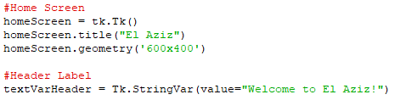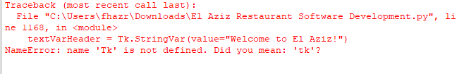
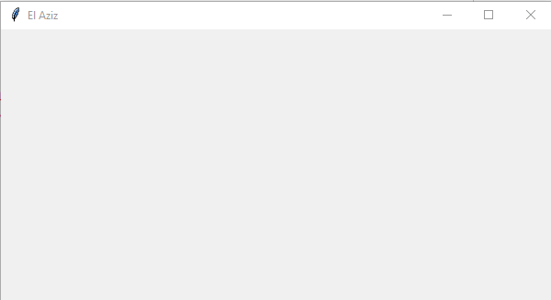
Solution:
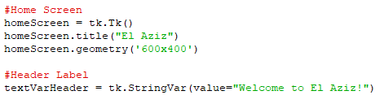
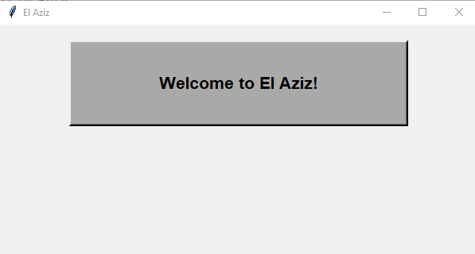

Test 2:
Test No. | Date | Test Description | Problem | Solution
2 | 08/12/25 | When creating the ‘Create Account’ and ‘Login’ buttons to gather user input during GUI creation. | When creating the buttons, I referred to the screens that the button would lead to rather than where the button would be display. I did this because it also referred to the command it would play, so I thought it was standard formatting. However, the accountScreen and loginScreen hadn’t been created yet, so the buttons were not displayed anywhere. Since both screens hadn’t been defined yet, nothing could be displayed. | I changed both the screen names to ‘homeScreen’ which meant the buttons would be displayed on the homeScreen. The command account_creation and login would be performed when the user clicked the button.

Error Screenshot:
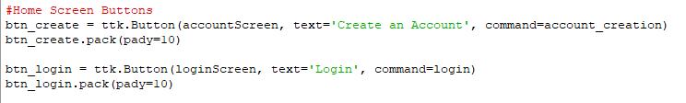
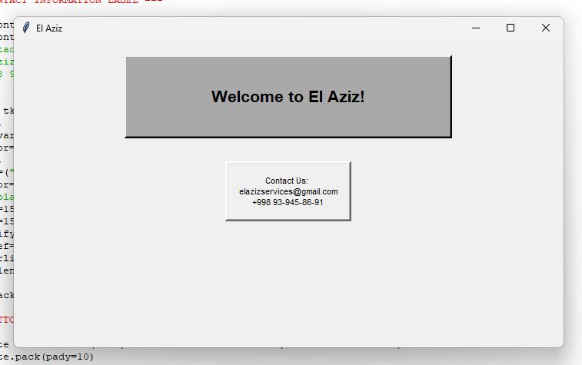

Solution:
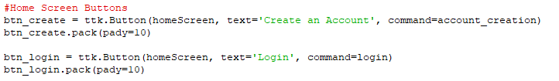
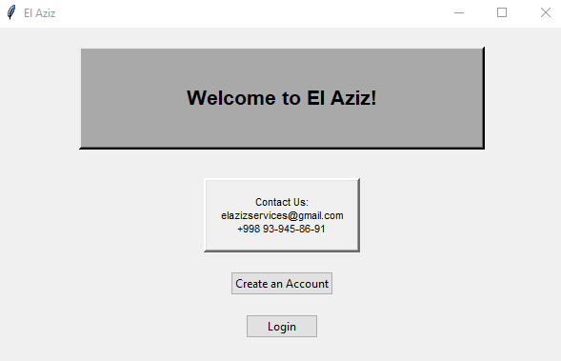
Test 3:
Test No. | Date | Test Description | Problem | Solution
3 | 9/12/25 | When creating GUI, creating selection boxes/checkboxes to select role when creating an account. | Syntax error- I spelt the word ‘variable’ as ‘varable’ for all 3 radio buttons, which is incorrect. It led to no display of the buttons. | Corrected my spelling from ‘varable’ to variable for all 3 radio buttons, and it displayed the buttons after.

Error Screenshot:
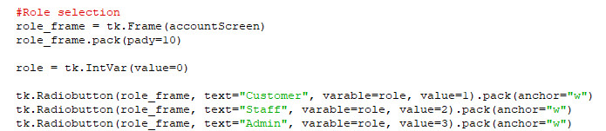
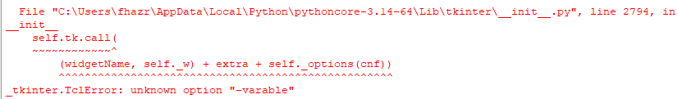
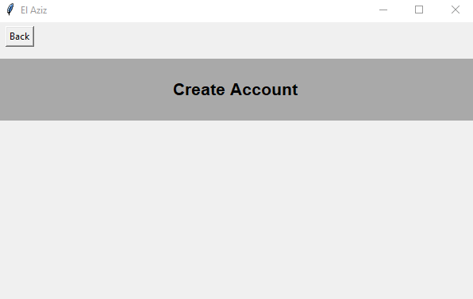
Solution:
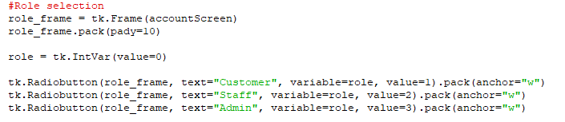
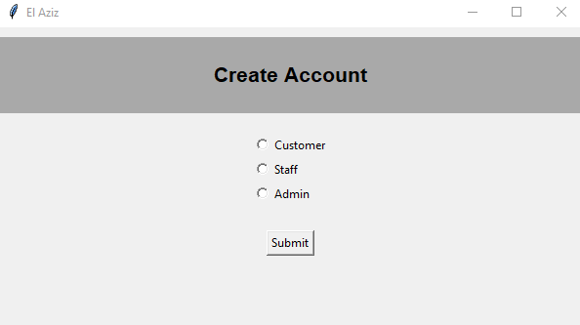

Test 4:
Test No. | Date | Test Description | Problem | Solution
4 | 9/12/25 | Once account created, generating a unique ID with their role prefix. | When generating the unique ID, I didn’t clarify that the len(firstName.get()), len(surname.get()) etc. were to be of a string. This produced a type error since I was trying to join a word and number together. It resulted in no unique ID’s being generated for all customers, staff and admin. | I converted len(firstName.get()), len(surname.get()) etc. into strings by placing str() infront of the all len(entry field.get()’s. This then successfully generated unique ID’s for all user roles, inserting these into the database related to their role.

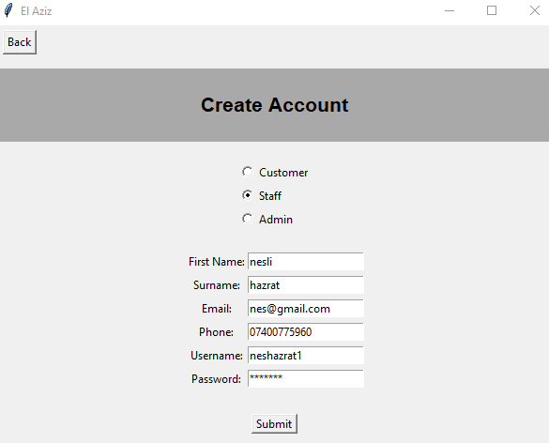
Error Screenshot:
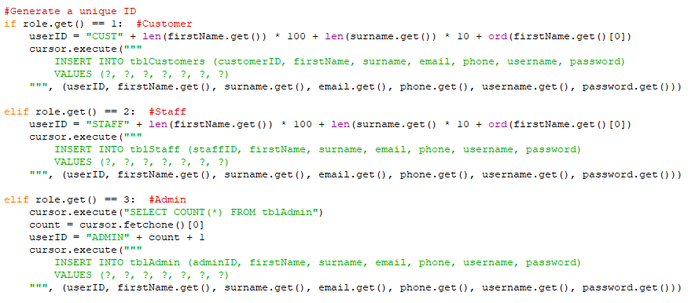
Solution:
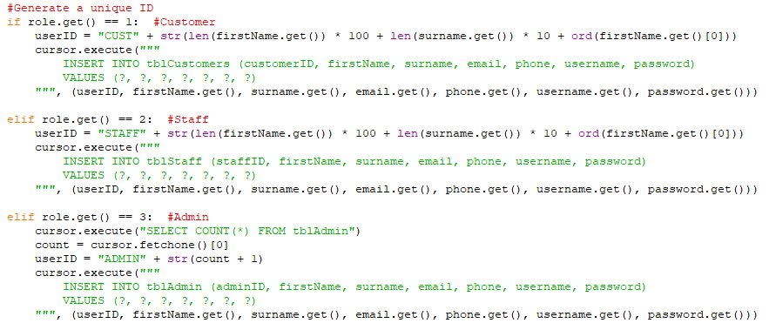

Test 5:
Test No. | Date | Test Description | Problem | Solution
5 | 11/12/25 | Inserting user inputs/entries into their relevant database table based on user role. | As I was constantly running and closing my program, the tables within ‘El Aziz.db’ had already been created. When I re ran the program, data wouldn’t be inserted since the table already existed. I didn’t include the option to clear/delete data because restaurants need to have all records, regardless of time period. This caused the program to crash and not respond, because data could not be inserted. | My original databases used the command ‘CREATE TABLE tbl..’, which was causing issues since this program was going to be run multiple times. To stop this, I used the command ‘CREATE TABLE IF NOT EXISTS tbl..’ which tells SQL to only create the table if it doesn’t exist. If it does, SQL will carry on, with no errors.

Error Screenshot:
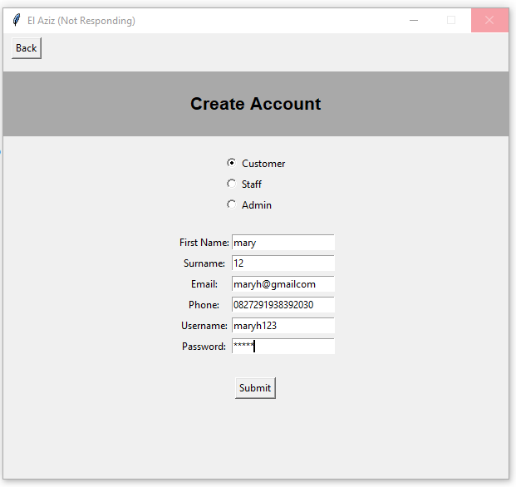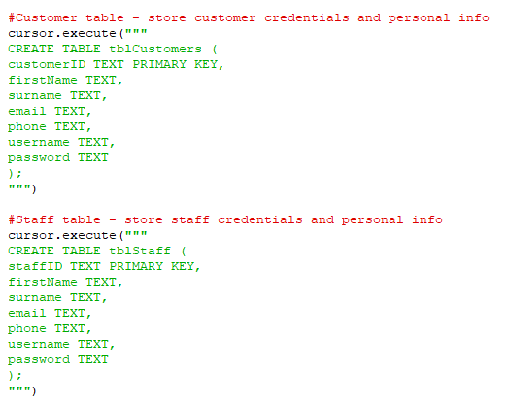
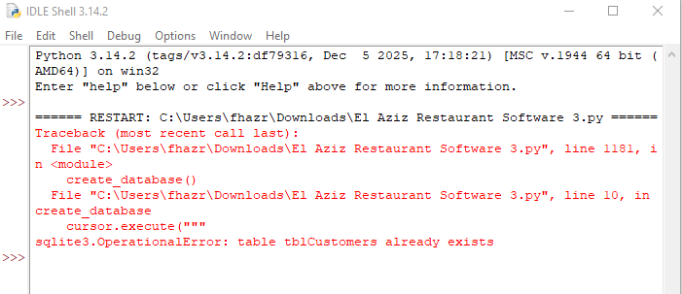

Solution:
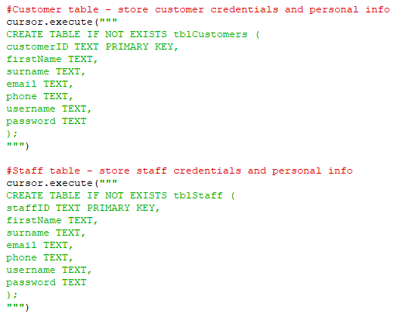

Test 6:
Test No. | Date | Test Description | Problem | Solution
6 | 22/12/25 | Storing and recording user login/entries by logging them, inserting into tblLoginLogs. | I had closed the database before asking SQL to insert into tblLoginLogs, despite preivosuly writing ‘ connection.close()’ . | To fix this, I removed the ‘conneciton.close()’ from before inserting into the table. I then also used try and except to prevent the crash, and handle the errors simply.

Error Screenshot:
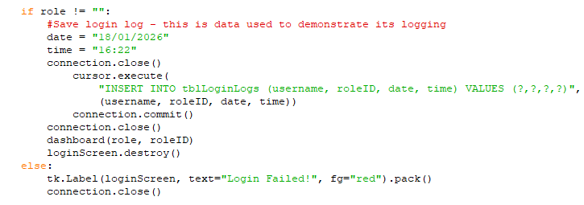
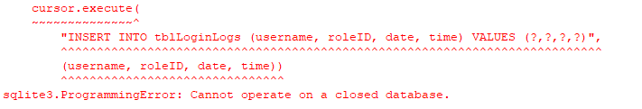
Solution:
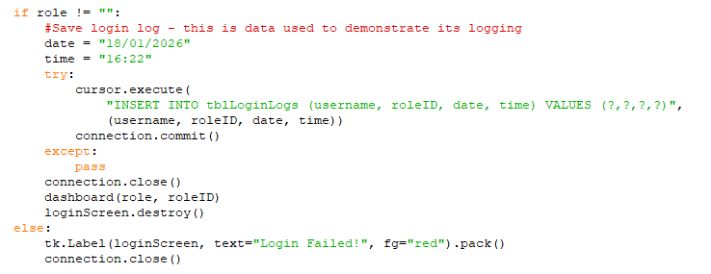

Test 7:
Test No. | Date | Test Description | Problem | Solution
7 | 30/12/25 | GUI Creation – creating a listbox and scroll bar for the menu to ensure all menu items are visible without adjusting window size. | The issue was that when configuring the scrollbar, I commanded it without a real attribute. The command .view isn’t a real list box command and the program prompted me with ‘x.view’. However, my scrollbar was a vertical scrollbar. | To fix this, I changed ‘command = mylist.view’ to ‘command=mylist.yview’ which meant the bar could scroll up and down (vertically).

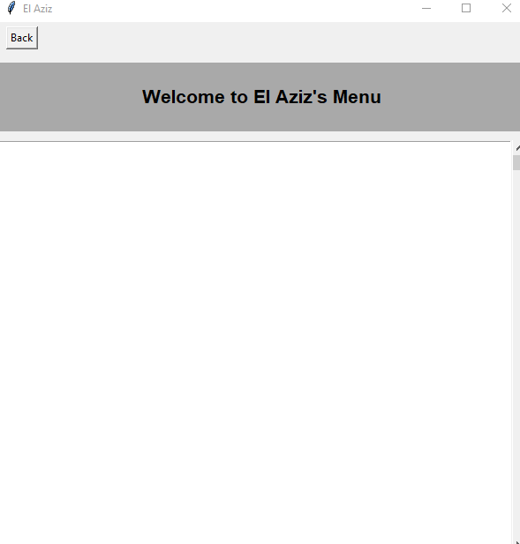
Error Screenshot:
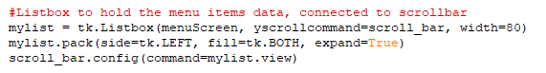

Solution:

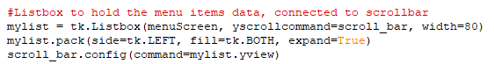

Test 8:
Test No. | Date | Test Description | Problem | Solution
8 | 1/01/26 | Displaying all menu item inside the list box in descending order. | I had defined ‘all_items = []’ which cleared the whole list before the loop ran to display all menu items. This lead to no display of menu items. | I removed the ‘all_items = []’ part which contained the sorted menu items. The loop ran and displayed all menu items normally.

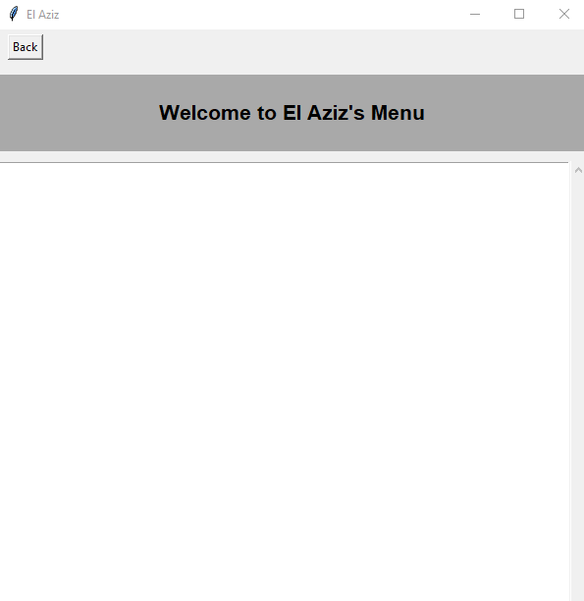
Error Screenshot:
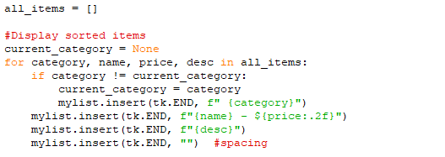

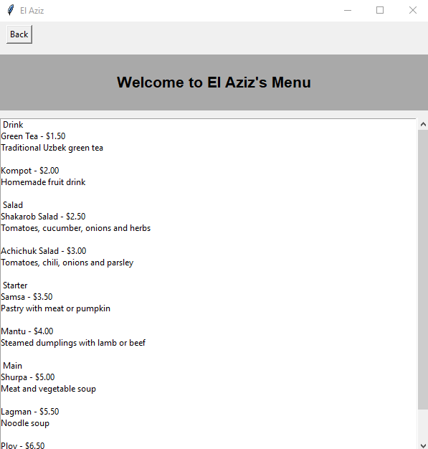
Solution:
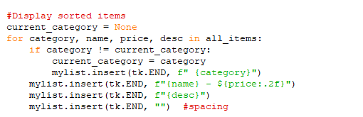

Test 9:
Test No. | Date | Test Description | Problem | Solution
9 | 4/01/26 | Bubble sorting the menu items by their prices for users to browse the menu. | Index Error produced, the list index is out of range. I used n= n + 1 which increased n by 1 for each pass, when it should’ve decreased by 1. This caused he list index to be out of range, since the menu items range is increasing more than the list. I also accidentally used the wrong inequality, which made the sort swap items in the wrong direction, producing an incorrect sort. | To fix this, I changed ‘n = n + 1’ to ‘n = n - 1’ to correctly decrease ‘n’ by 1 for each pass. I then changed the inequality from ‘<’ to ‘>’ to correctly sort the items by price. This changed it so that it would swap when the current item price is bigger than the next menu item price, rather than when the current items price is smaller. This sorted and displayed the menu items correctly.

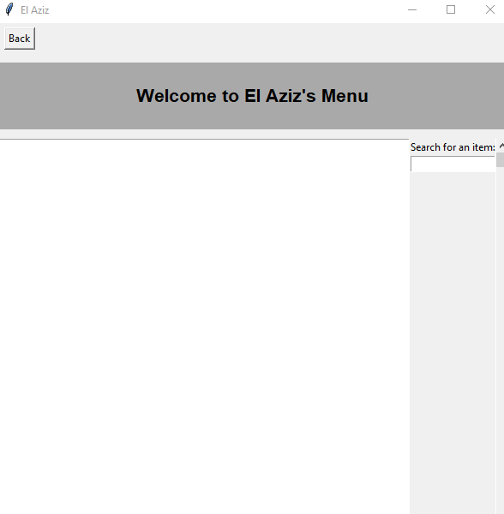
Error Screenshot:
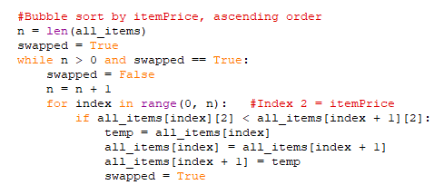
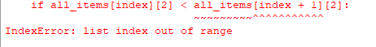
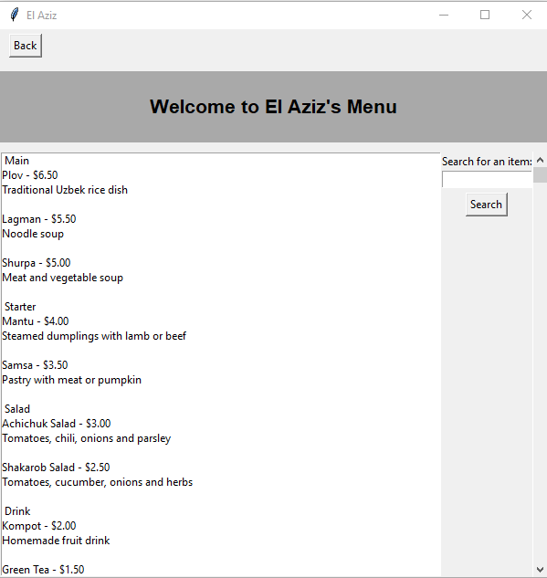
Solution:
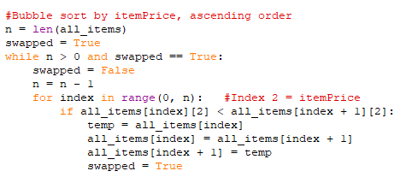

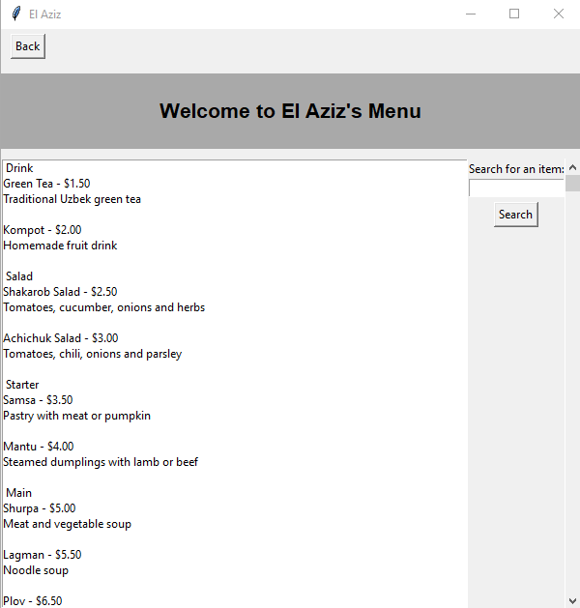
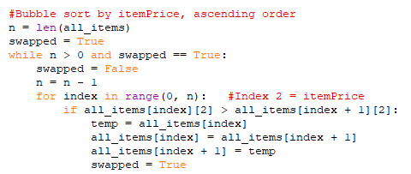

Test 10:
Test No. | Date | Test Description | Problem | Solution
10 | 4/01/26 | Searching for menu items by item name via binary search. | Incorrect binary search results. When I searched for an existing menu item, it told me ‘Item not found’ when it should’ve listed the item name, told me if it has been found and its price. | I was unable to get the binary search to efficiently work. It still says the menu item is not found despite it existing. It may be related to the bubble sort I coded earlier on, sorting the menu items by price. I produced the sort since it’s required for a binary search.
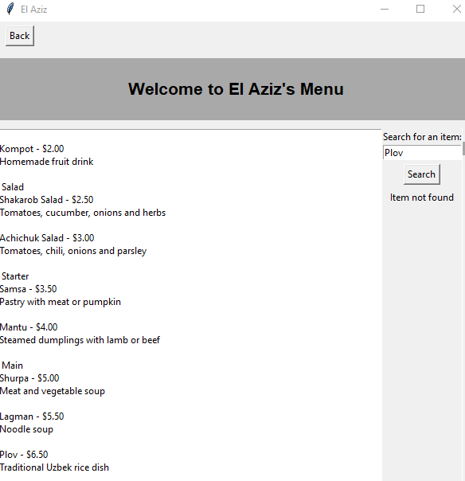
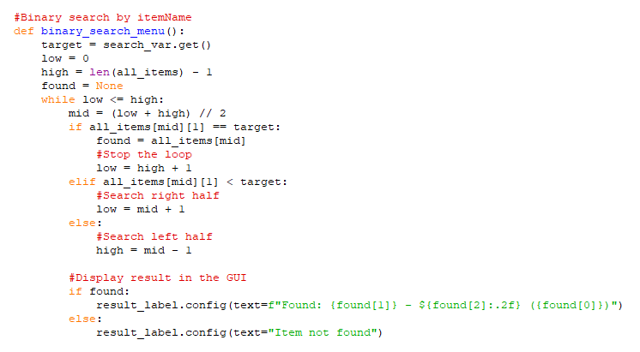
Error Screenshot:

Solution:
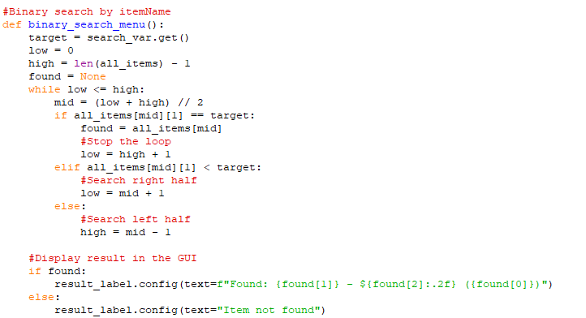

Test 11:
Test No. | Date | Test Description | Problem | Solution
11 | 14/01/26 | Updating the total of the order when users select items and specify item quantity. | The total wasn’t being calculated correctly, since it used ‘=’. This meant it would wipe out the previously selected and specified item, only using the last selected item and quantity. This led to incorrect totals being displayed. | I used ‘+=’ instead of ‘=’ which added each item on top of what was already selected and specified. It used previously calculated totals and added it on top of the new item selection. This led to correct totals being displayed.

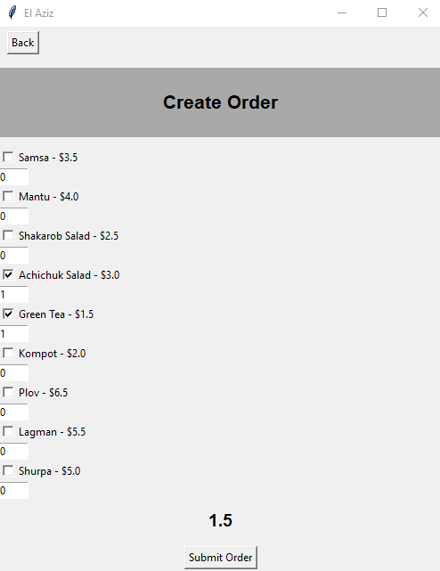
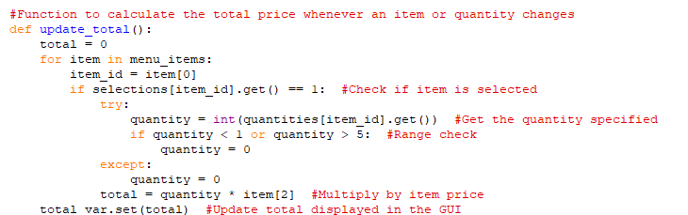
Error Screenshot:
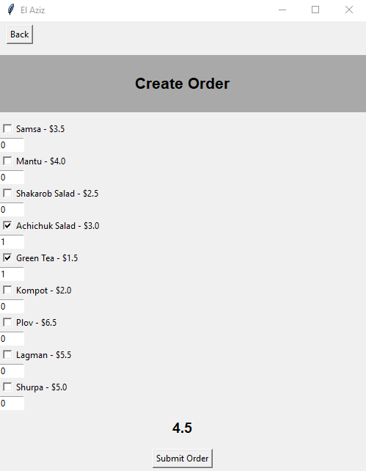
Solution:
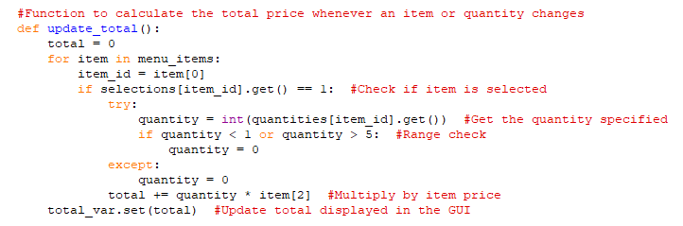

Test 12:
Test No. | Date | Test Description | Problem | Solution
12 | 14/01/26 | Inserting user entries into tblOrders, storing their customerID, menu item and total price. | SQL error was produced since there was no column in tblOrders called ‘total’ where I meant to write ‘totalPrice’. I then accidentally left 4 values for 3 columns which couldn’t store anything with the additional value. | I changed ‘total’ to ‘totalPrice’ which is the name of the column in tblOrders. I then removed one of the question mark values, allowing 3 columns to correspond to 3 values.

Error Screenshot:
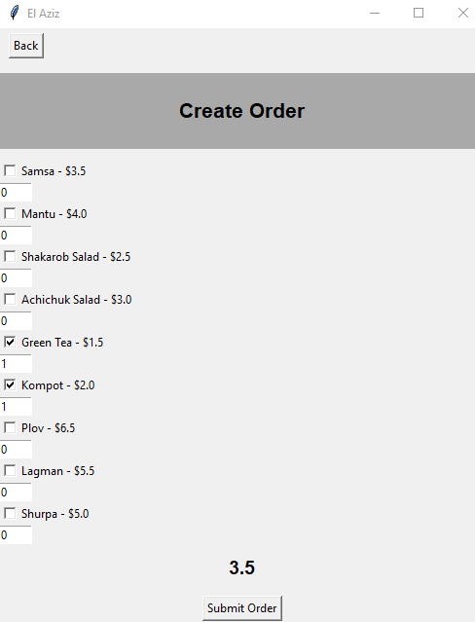
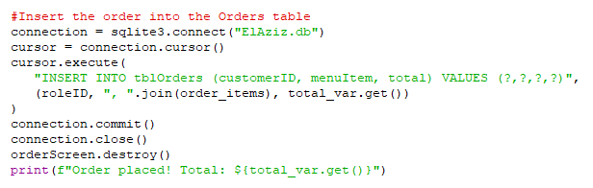
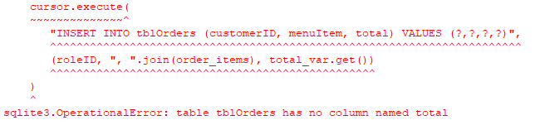
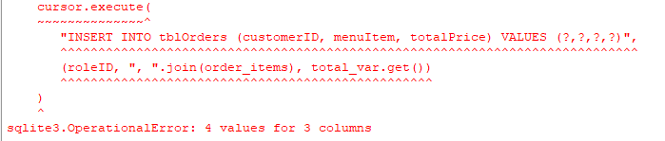

Solution:

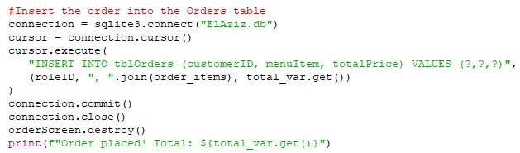

Test 13:
Test No. | Date | Test Description | Problem | Solution
13 | 17/01/26 | Successfully submitting a reservation. | A TclError was produced claiming a bad window path name. The reservation would not submit due to this error, despite all entries being valid and acceptable. The program kept running until it tried to interact with a window or widget which was invalid, hence the bad window path name error. | This was due to the absence of ‘return’. I added the ‘return’ underneath each validation check/if statement. By adding return, it stopped the code form running further past failed validation.

Error Screenshot:
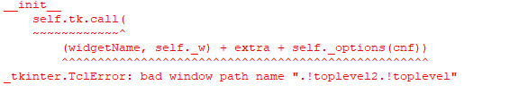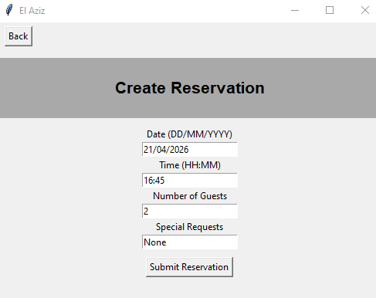
Solution:


Test 14:
Test No. | Date | Test Description | Problem | Solution
14 | 19/01/26 | Searching orders and reservations by their unique ID numbers. | When searching for an existing reservation, the program would crash, claiming ‘bool’ object is not subscriptable. I tried to fix this by adding in the ‘index = index + 1’, index incrementing, since I realised I forgot it. But even after this, it would display ‘Order/Reservation not found’ despite the ID numbers being valid and existing. | The search reservation and order by ID, now accept inputs. However, it searches incorrectly or displays an incorrect message. It returns ‘Order/Reservation not found’ despite the ID being valid and real.
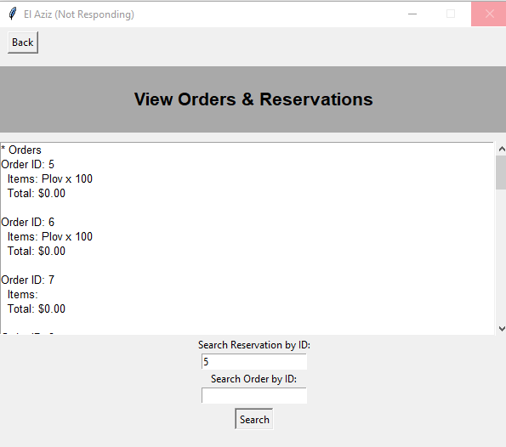
Error Screenshot:
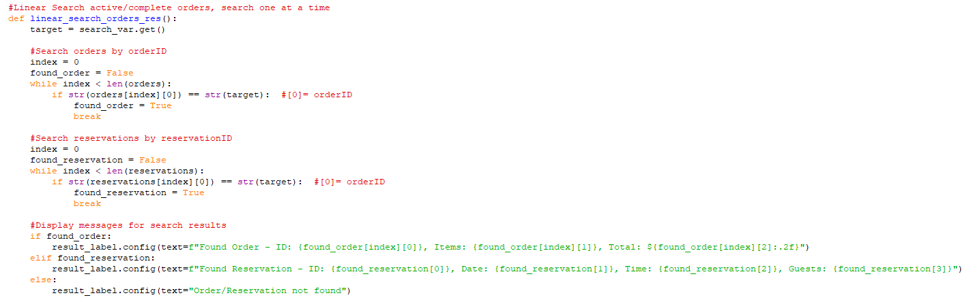

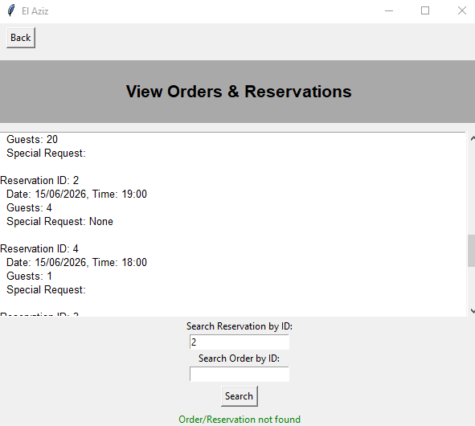
Solution:
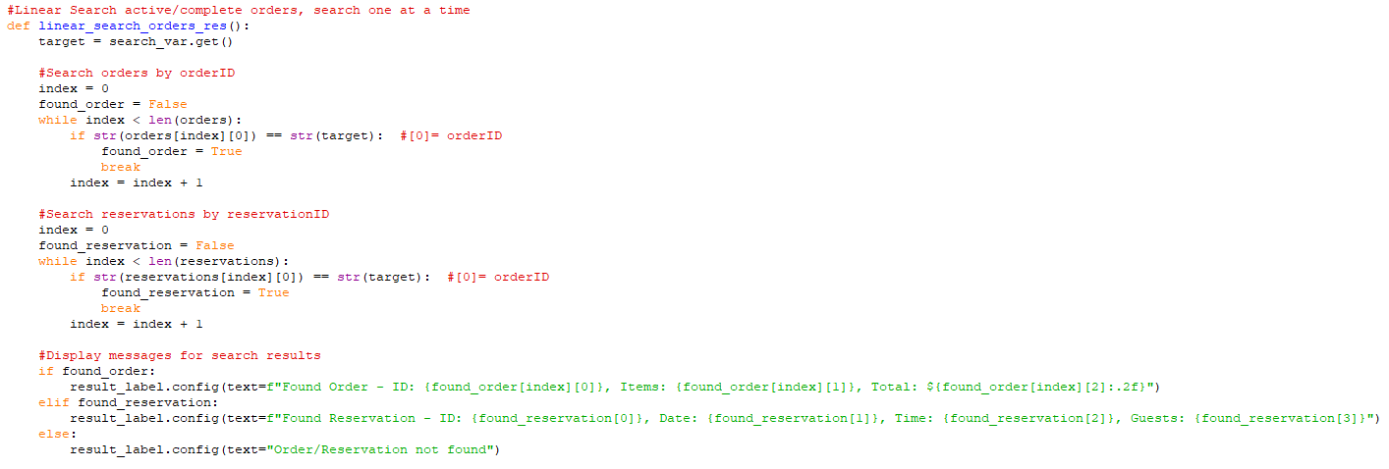

Test 15:
Test No. | Date | Test Description | Problem | Solution
15 | 27/01/26 | Searching for shifts, by StaffID, belonging to the logged in staff member, via Linear search. | When the program searched for shifts, it displayed ‘No shifts found’ despite all staff having one shift inserted automatically. This was because I had used incorrect indexing, starting from 1 rather than 0. | I changed my indexing starting from 1, changing it to 0. This meant the program could search the shifts and display the correct information such as their staff ID, shift Id, date, hours and their start/end times.

Error Screenshot:
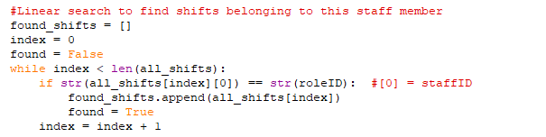
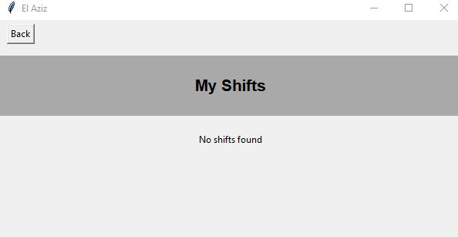
Solution:
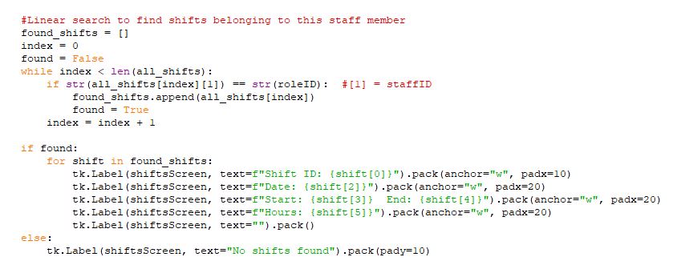
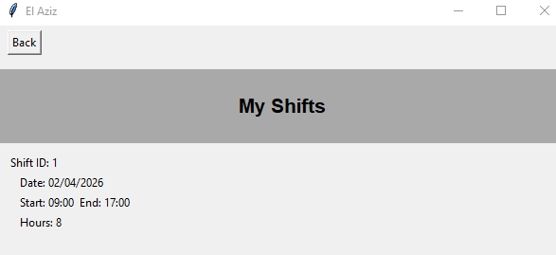
Test 16:
Test No. | Date | Test Description | Problem | Solution
15 | 2/02/26 | Retrieving and displaying all relevant database tables and their records for staff to view.

Error Screenshot:
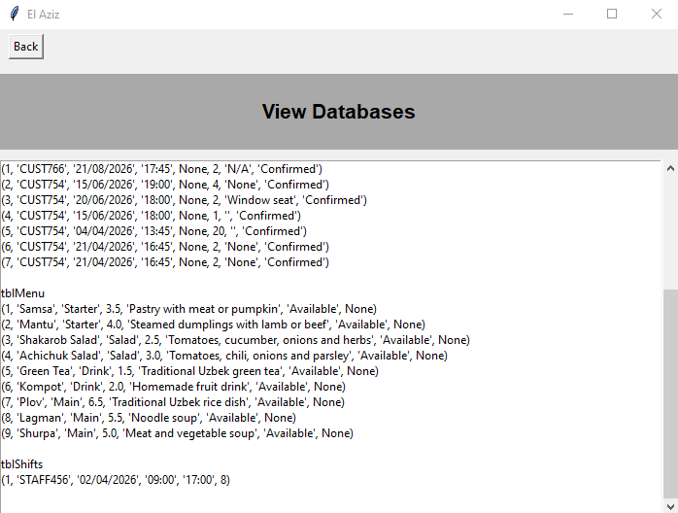
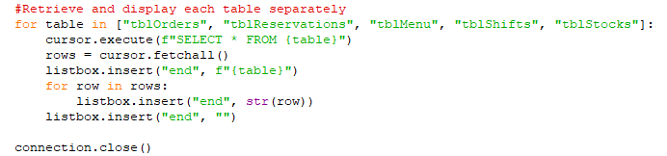
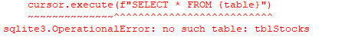

Solution:
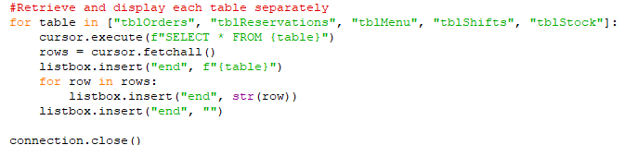
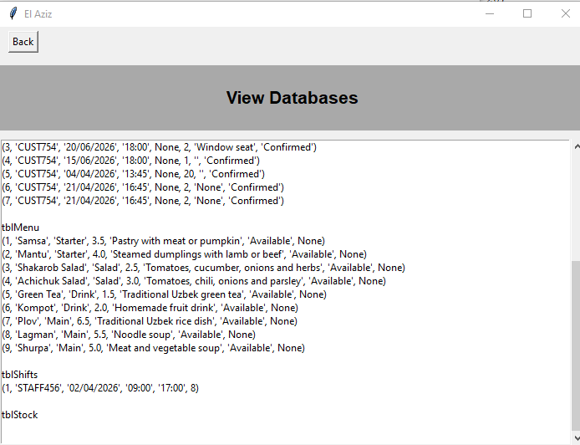

Test 17:
Test No. | Date | Test Description | Problem | Solution
16 |  |  |  | indentation

Error Screenshot:
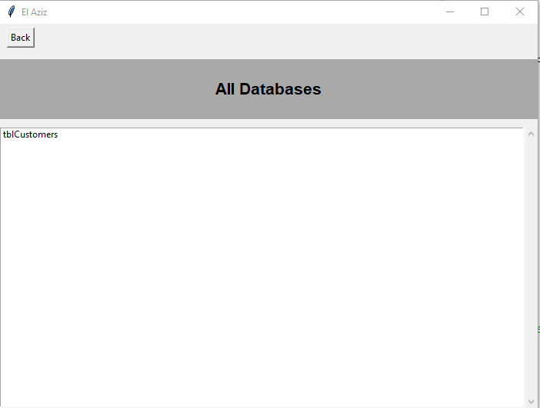
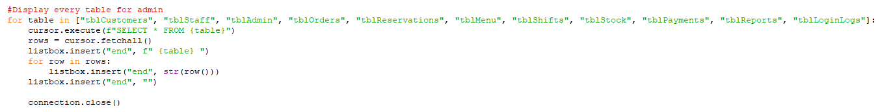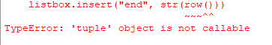

Solution:
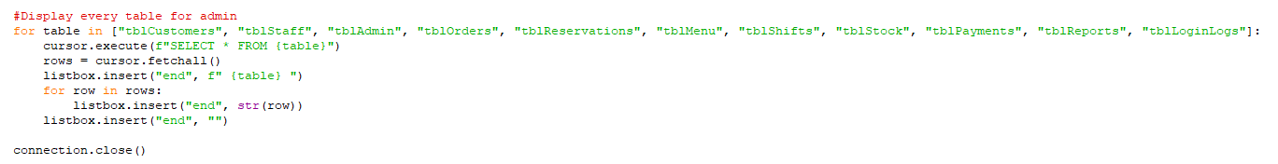
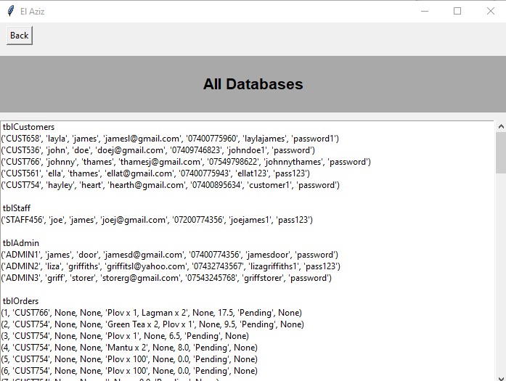

Test 18:
Test No. | Date | Test Description | Problem | Solution
17

Error Screenshot:
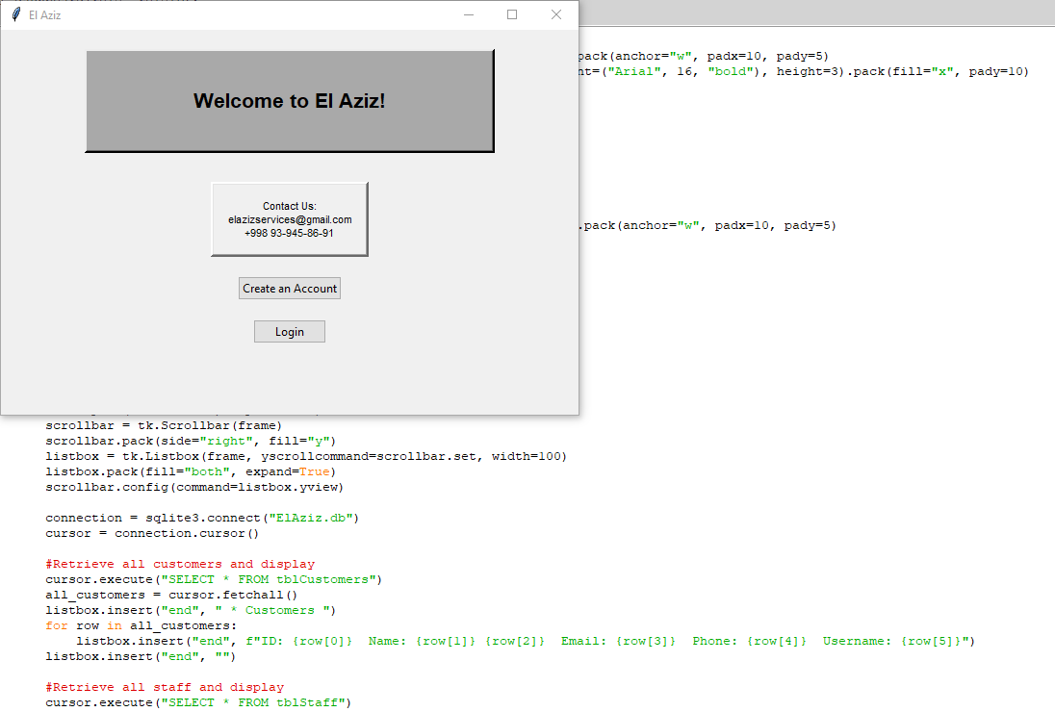
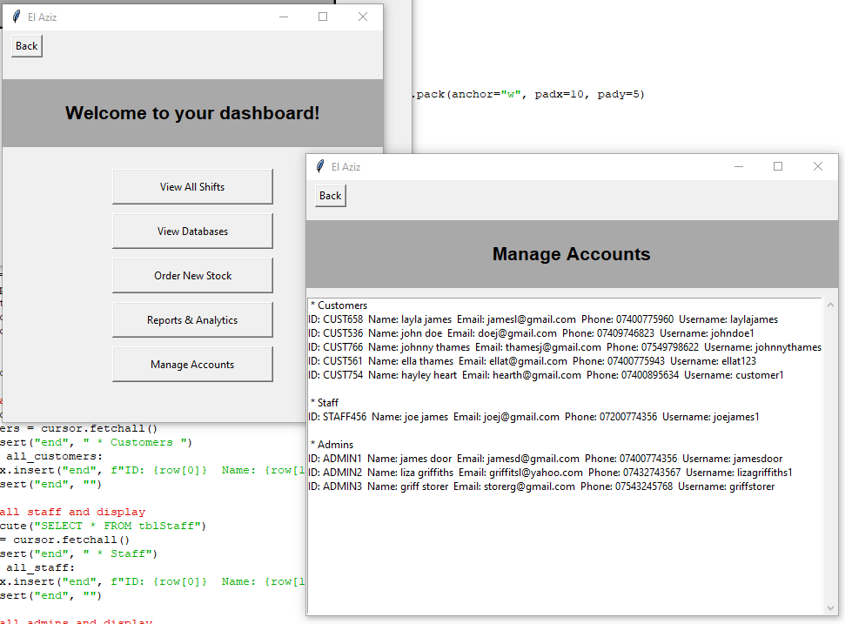
Closes both
Solution:
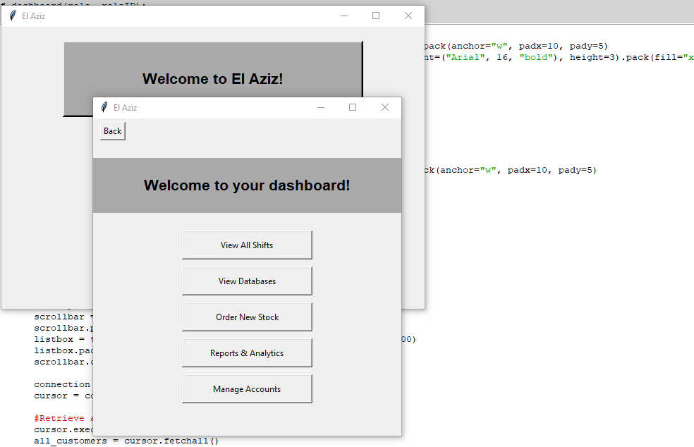

Test 19:
Test No. | Date | Test Description | Problem | Solution
18

Error Screenshot:
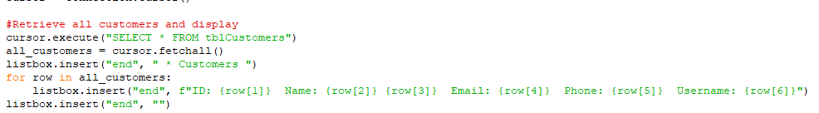
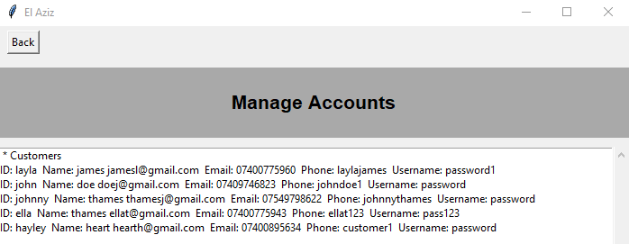
Solution:
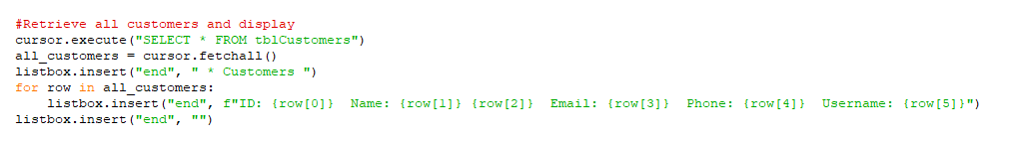
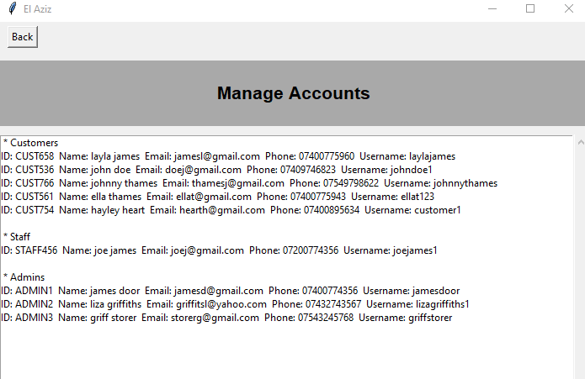

Test 20: Managing all accounts:
Test No. | Date | Test Description | Problem | Solution
18

Error Screenshot:
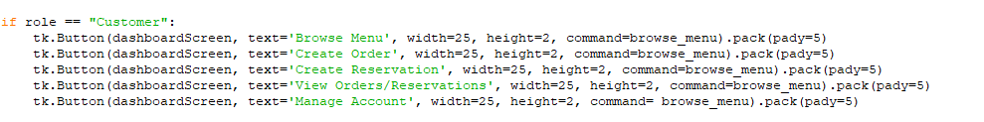
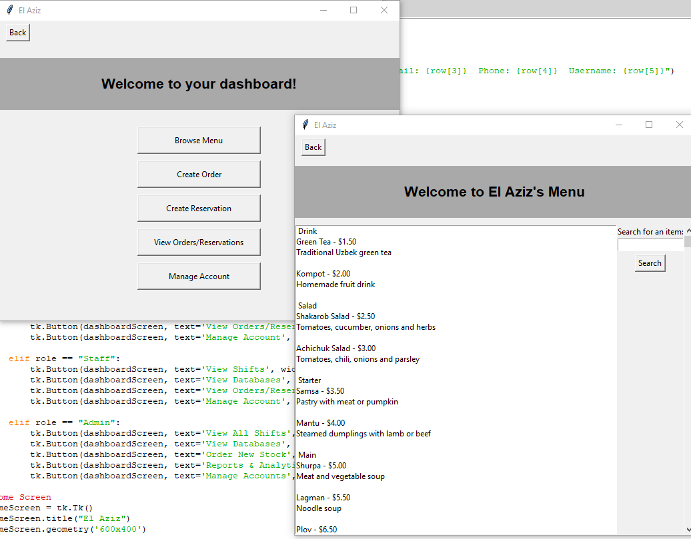
Solution:
